**How to use the attributes Selection app**

1. unpack AttributeSelection.zip file. And run AttributeSelection.exe on your own computer. The GUI will show like this. You may see some Chinese in the picture, it follows the system settings.

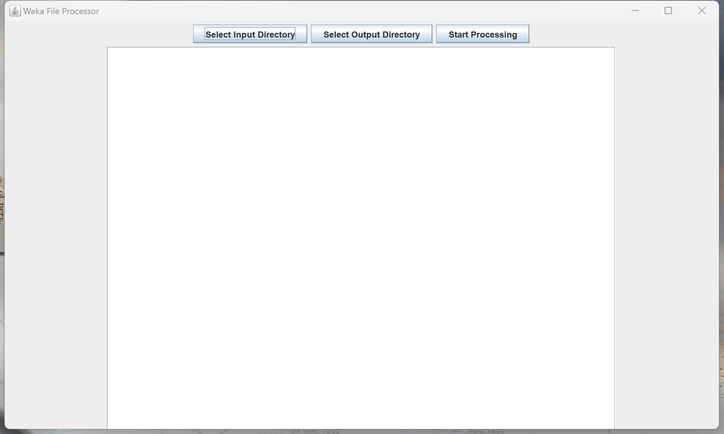

2. Press Selection Input Direc Button, the folder ”Dataset 1 CoreA file” is a sample file contain 6 “.arff” files. Please do not process files with the suffix '_selection', as the algorithm already skips files with this suffix to prevent entering an dead loop during processing.

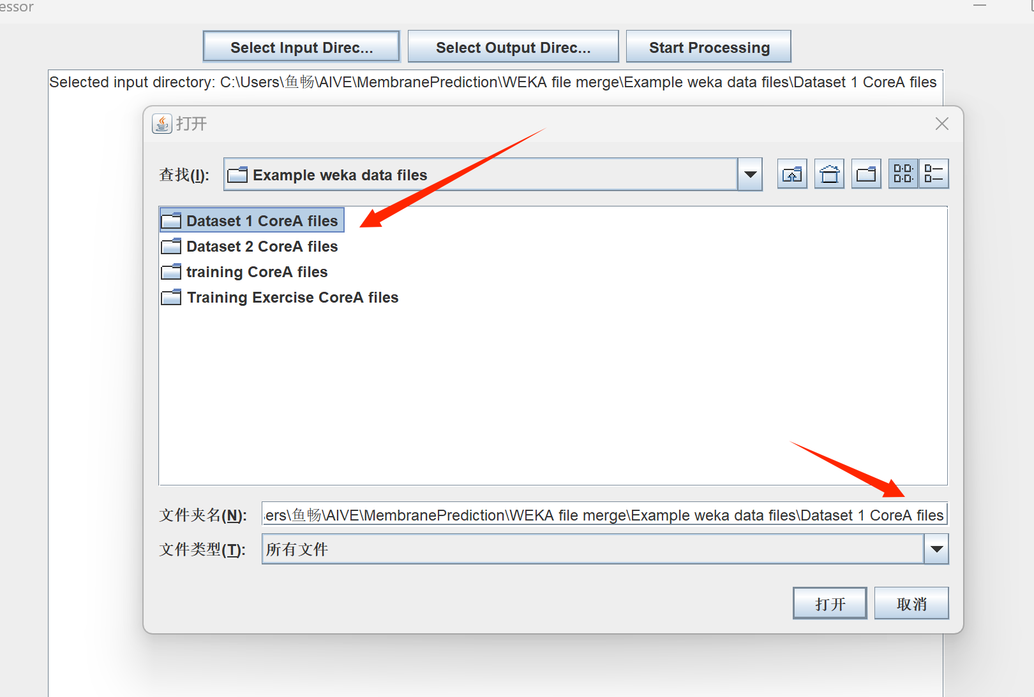



3.Then press ”Selection Output Direc” Button, that’s the output file direction, you can choose as you need. And press “Open”.

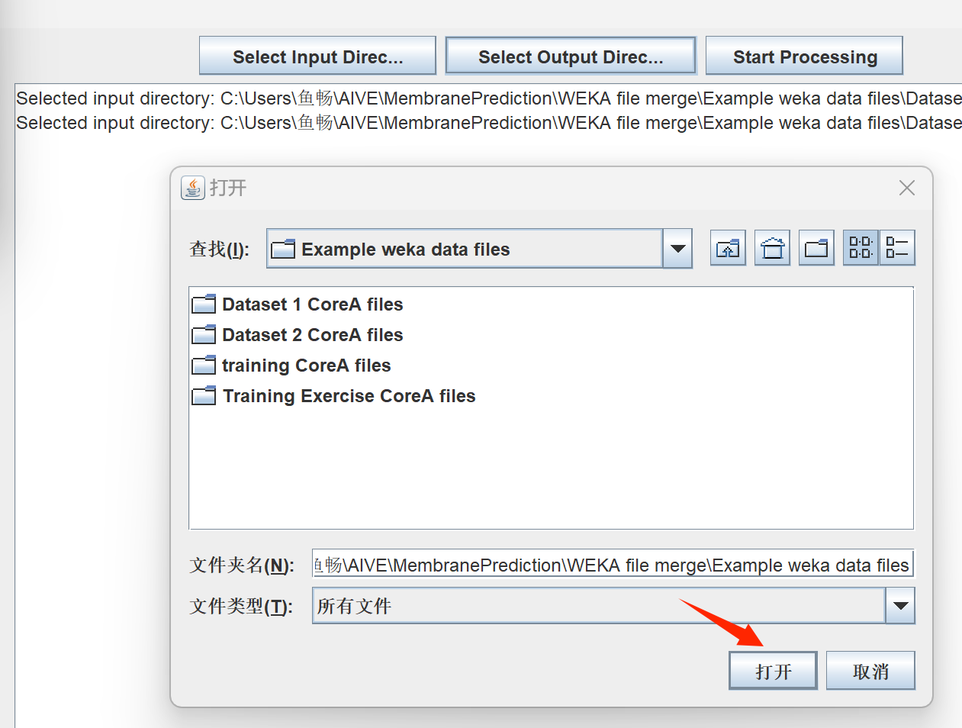

4. Then you can Start Processing. When processing is finished, you can see the “Processing completed” down below.

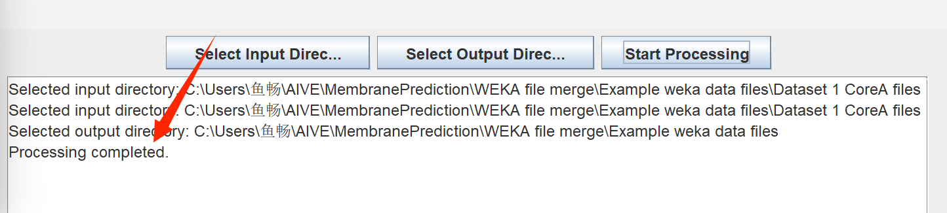

5. And you can find your new files in the folder, and also the log file. The new file name will be have the suffix“_selection” after the original filename. It’s a good way to track the source.

And also a “process_log.txt” file, you can check the details in the log file, including the number of original and new “.arff” attributes.

